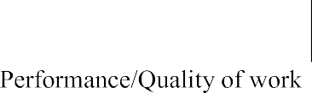



Prashant Srivastava

Ehandler

EE



|  |  |  |  |  |  |
| --- | --- | --- | --- | --- | --- |
|  |  |  |  |  |  |
|  | |  |  |  |  |
|  |  |  |  |  |  |
|  |  |  |  |  |  |
|  |  |  |  |  |  |
|  |  | | | | |
|  |  | | | | |
|  |  | | | | |
|  |  | | | | |

|  |  |  |  |  |  |
| --- | --- | --- | --- | --- | --- |
|  |  | of |  |  |  |